All students deserve to learn in classroom that is free of distraction. Therefore, I have the following rules, rewards and consequences in place to ensure that all students have the opportunity to learn and to do well in a safe classroom environment. Keep in mind that these classroom rules are in addition to the school rules/policies that are in the student handbook.
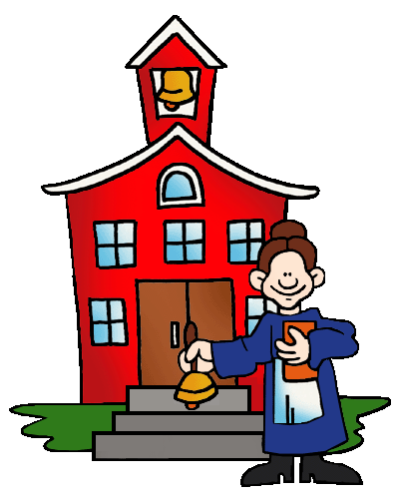
Classroom Rules: Be Respectful
Be Prepared
Be On Time
Be Reliable
Be your Best
Consequences
Consequence Number One: "Warning."
Consequence Number Two: “Parent or guardian contact.”
Consequence Number Three: “Referral.”
*Please know that all the above consequences depend on the severity of the rule broken. Some may result in immediate principal and parent contact.
Rewards
Students that choose to follow the classroom rules will be rewarded with good grades as well as special lessons /projects that they will be able to participate in during the school day. Other rewards possible are: earning bonus points to add to grades, gift certificates for the school book store, Guessing Jar chances and more.
Required Materials for Every Day:
1) Pencils/Pens (Any Colors)
2) Highlighters (Any Color)
3) Crayons or colored pencils (no more than 24 count)
4) Folder
5) Chromebook
6) Ear Buds
7) Highlighter

Textbook:
1) Students will utilize the textbook online.
2) Students will have access to an audio textbook.
* The Textbook and Audio Textbook can be found on our classroom website: mrcasey.educatorpages.com
Grading: The social studies grade will be based on percentages using three categories.
1) Tests 40%
2) Quizzes 30%
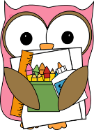
3) Other 30%
I do not give you a grade; you earn it!
Parents and students should check Skyward on a regular basis. You are always able to check your progress.
Tests/Quizzes/Other
1) Tests will be announced approximately one week in advance (A group review will help to prepare you for each test as well as a study guide.) Tests will be given on the computer and students will be able to use their book/resources to help them. The daily bell ringer will count as a test grade. HONORS: Article of the Month and Country Project will count as test grades.
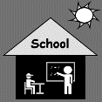
2) Quizzes may or may not be announced. (Review the day’s lesson each night, especially the vocabulary.) Take home quizzes also fall into this category. Quizzes will be given on the computer and students will not be able to use book/resources for quizzes.
3) Other These assignments include but are not limited to daily class work, class projects/activities and current events.
Curriculum: This will be an exciting year where we will extend our current knowledge and will get to try new things in our classroom. We will focus on past events in history as well as current events. We will also study the geography of civilizations discussed during the year. The following is a list of civilizations that we will study this year: The Beginnings of Human Society (Prehistory-2500 B.C.), The Fertile Crescent (3500B.C.-A.D. 300), Ancient Egypt and Nubia (3100 B.C.-31 B.C), The Rise of Ancient Greece (3000 B.C.-350 B.C), The Glory of Ancient Greece (700 B.C.-146 B.C), The Rise of Ancient Rome (900 B.C.-A.D. 192), The Fate of Ancient Rome (63 B.C.- A.D. 476). You may also go to our classroom website and click on the textbook tab to view a breakdown of each civilization.
Homework: Students will rarely have written assignments nightly unless they are absent or do not use class time appropriately. However, students should be spending 10 minutes a night reviewing vocabulary and/or material from the day. Homework is not just written, studying and reviewing is part of homework. Students should not be saying that they do not have homework.
Extra Credit: Our classroom website contains information on the only extra credit that will be offered throughout the school year. Please refer to our classroom website for information on extra credit: mrsholodick.educatorpages.com
Absences: You are responsible for all missed work during your time of absence. Work will be posted in our Google Classroom for students so that they will not fall behind. Checking Google Classroom will be important if you are unable to attend class.
Skyward: Skyward is a great tool to keep track of your child’s progress as well as what is happening in the classroom. All assignments are posted in Skyward as well as any important announcements that are necessary. Student’s grades are posted in Skyward in a timely manner. Skyward is also the best way to communicate with me. If you do not have access to Skyward, please contact Central Office for your username and password.
Remind: This is a fast and safe way to communicate throughout the school year. It allows messages to be sent and received while keeping the privacy of your phone number. It is a great way to stay in the loop with assignments, due dates etc.
Class Room Website: https://mrcasey.educatorpages.com
This site contains a link to the text book, extra credit, PowerPoints, vocabulary and more. This is an excellent source for students and parents to stay on top of what is going on in the classroom.

If at any time you are struggling with your social studies work or do not understand something, please do not hesitate to ASK ME FOR HELP.





